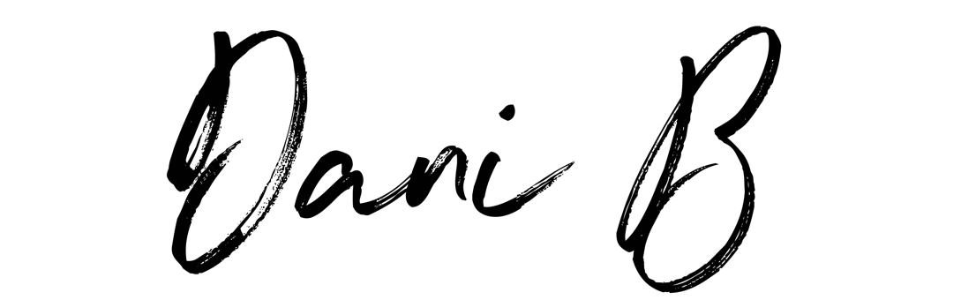

TECH RIDER

THE ARTIST TO PROVIDE

PIONEER RX3 DJ CONTROLLER
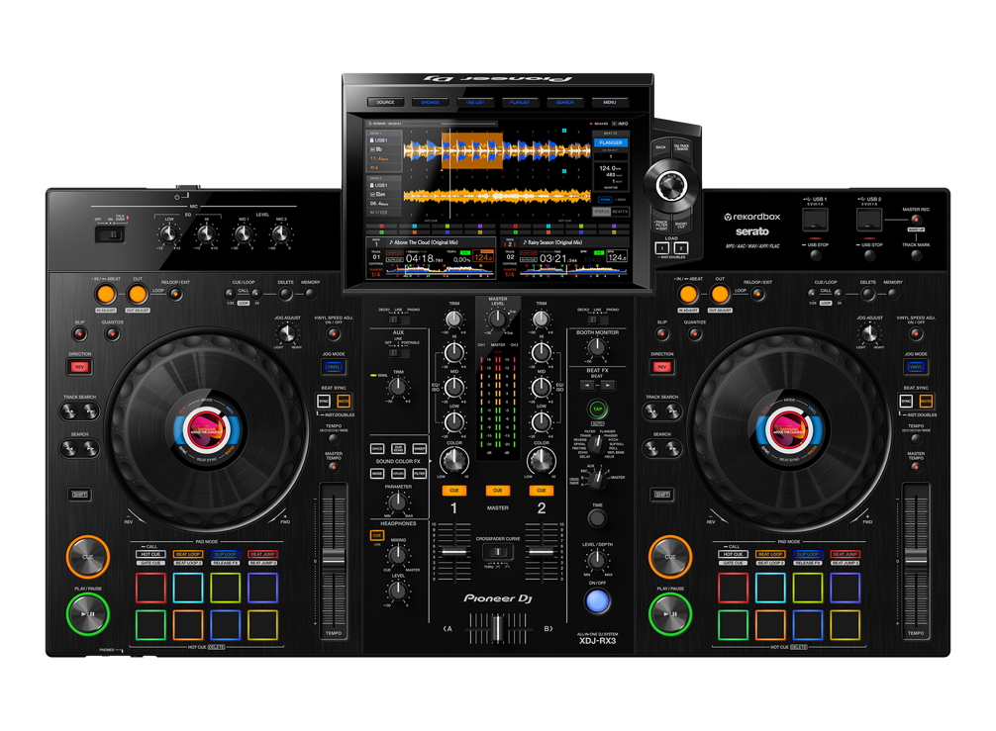
Size. W. 728.1 mm H. 118.4 mm D. 469.5 mm
Main Out XLR / RCA Inputs
Booth – Jack Input

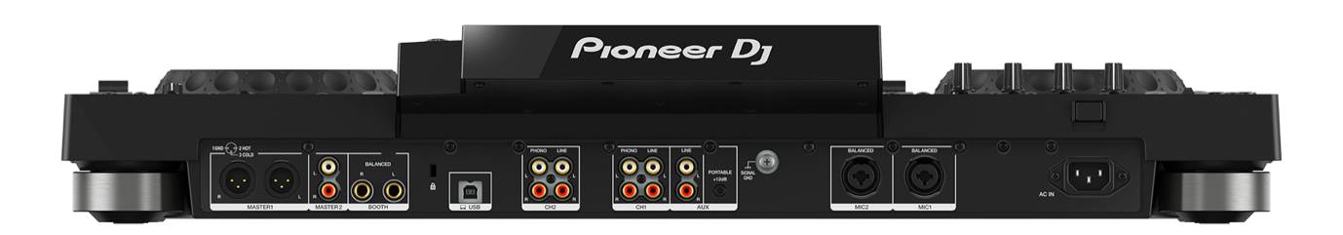

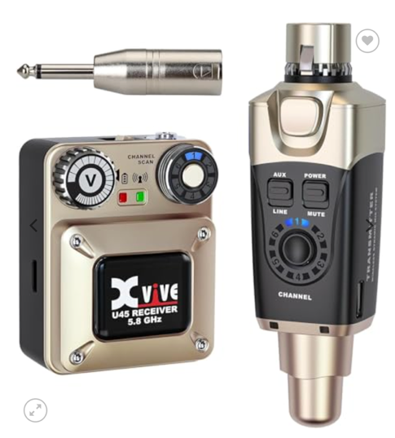
XVIVE U45 IEM

CLIENT TO PROVIDE:
PA 2 x Tops, Bass Bins
1X FLOOR MONITORS
WIRELESS PRO MIC (SHURE / SENNHEISER). (Good Range)
DJ Booth
Mic Stand
(No higher than 95/100 cm, Artist height is 160 cm) (or provide platform to stand on)
PRO MIXING DESK (WITH FX – REVERB Channel EQ)
*Need to control music and Vocal levels separately through Desk for IEM and floor monitor
(to EQ mix in IEM and Music and Vocal levels independantly)

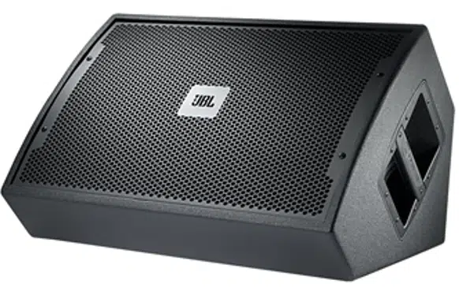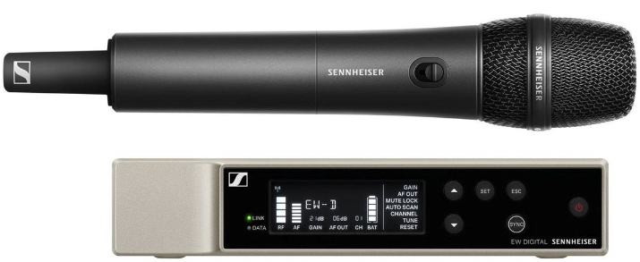
MONITOR WIRELESS PRO MIC (SHURE / SENNHEISER)

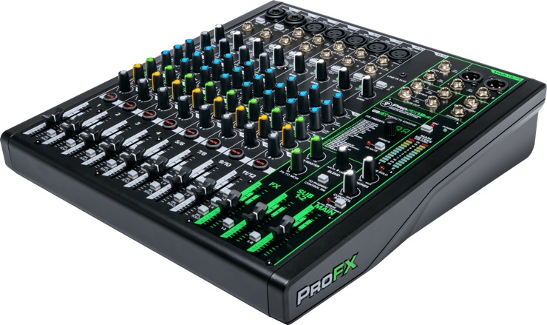
PRO MIXING DESK (WITH FX – REVERB)
(Soundcraft, Yamaha, Mackie ProFX, Allen & Heath)

